F14076083 魏湧致

5.14

(a) b(4;4,0.9) = $\left({4 \atop 4}\right){0.9}^{4}{0.1}^{0}$ = 0.6561

(b) P(X≥4) = $\sum_{x=4}^{x=7}{b(x;7,0.9)}$ = $\sum_{x=0}^{x=7}{b(x;7,0.9)}$- $\sum_{x=0}^{x=3}{b(x;7,0.9)}$

= 1-0.0027 = 0.9973

(c) Chicago Bulls每一場贏的機率是0.9

5.26

(a) b(6;8,0.6) = $\left({8 \atop 6}\right){0.6}^{6}{0.4}^{2}$ = 28×0.046656×0.16 = 0.20901888

(b) b(6;8,0.6) = $\sum_{x=0}^{x=6}{b(x;8,0.6)}$- $\sum_{x=0}^{x=5}{b(x;8,0.6)}$ = 0.8936 -0.6846 = 0.209

5.50

(a) b\*(7;3,0.5) = $\left({6 \atop 2}\right){0.5}^{3}{0.5}^{4}$ = 15×0.0078125 = 0.1171875

(b) b\*(4;1,0.5) = ${0.5}^{1}{0.5}^{3}$ = 0.0625

5.80

(a) P(X≤4) = $\sum_{x=0}^{x=4}{p(x;2.7)}$ = $\sum_{x=0}^{x=4}{\frac{e^{-2.7}{2.7}^{x}}{x!}}$ = 0.8629

(b) P(X≤1) = $\sum_{x=0}^{x=1}{p(x;2.7)}$ = $\sum_{x=0}^{x=1}{\frac{e^{-2.7}{2.7}^{x}}{x!}}$ = 0.2487

(c) 2.7×5 = 13.5 P(X>10) = 1 - P(X≤10) = 1 - $\sum_{x=0}^{x=10}{\frac{e^{-13.5}{13.5}^{x}}{x!}}$

= 1- 0.2112 = 0.7888

Matlab

1.(e)下面四張圖分別為題目的四種情況，n都是10的4次方，p分別為0.01, 0.1, 0.2, 0.5，可以看出p越小Binomial和Poisson的曲線就越接近，與課本定理的結論相同。

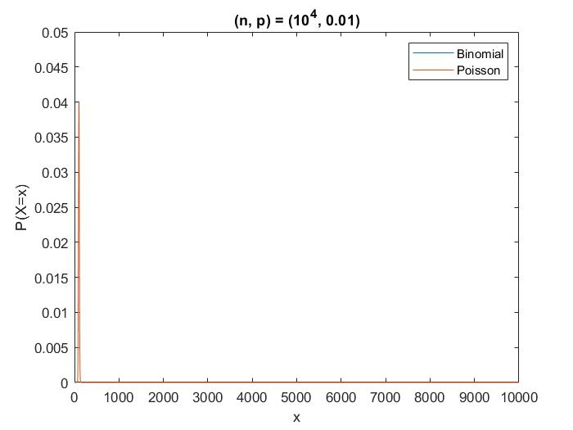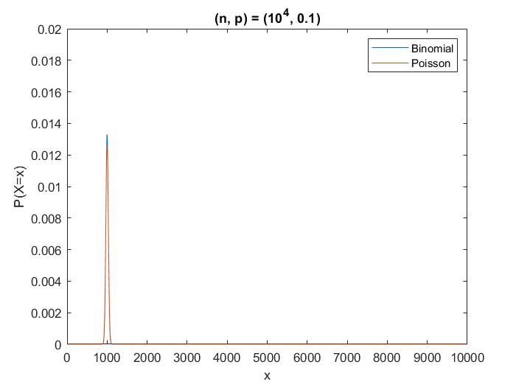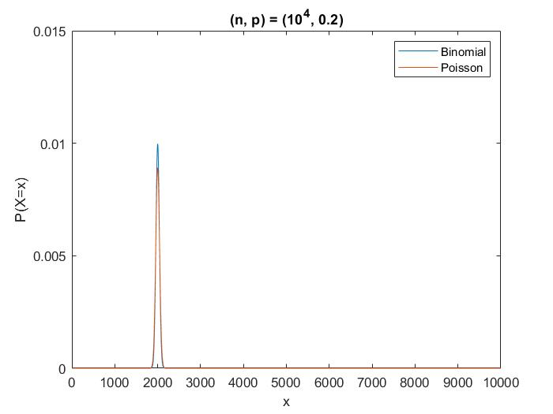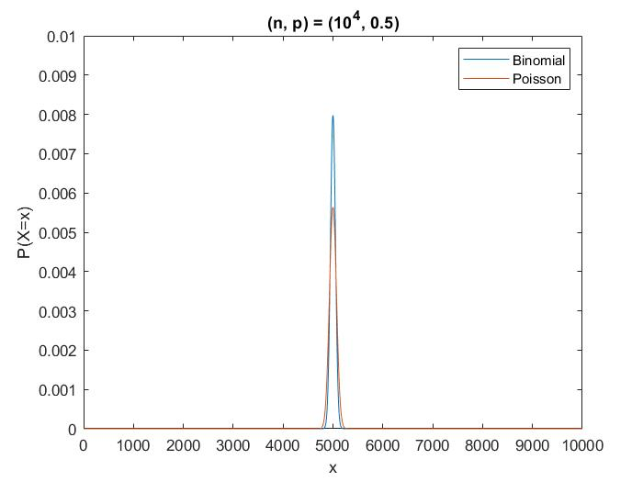

2.(a)

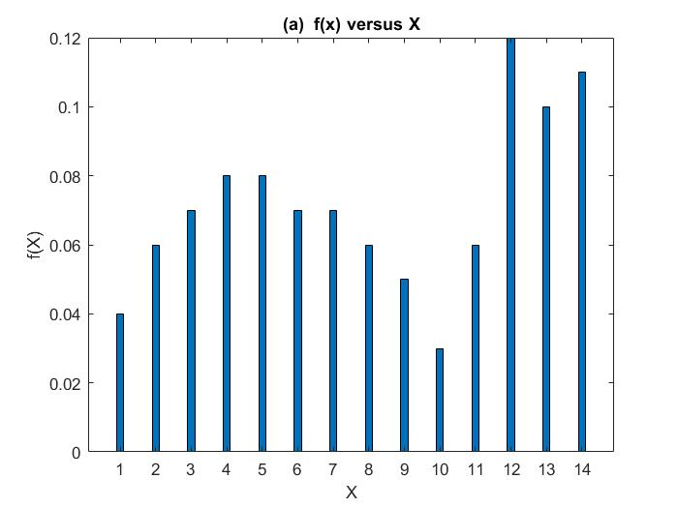

2.(b)因為是透過X的機率分布來生成10^4個sample，數量很大所以比較偏差比

較看不出來，所以與(a)的圖非常相似，

